**Template:**

* .j2 file means jinja2 file format

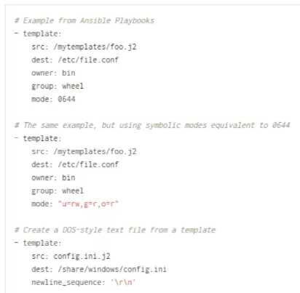

* Example, we want to change the port. Manually, we change it in server.xml
* But in ansible, we create a template file with the exact copy of server.xml in the place where we using the port number, we replace it with the variable and rename the file as .j2 format
* During run time, we use template module, this file with .j2 will copy to actual server.xml and the number will be replaced to variable
* Like this, where ever we want to change the value, we use variable there and rename the file with .j2
* After this, we may need to restart or reload service, such things we do with handlers

**Template module to change the tomcat port:**

* Copy the server.xml file to another location
* In that file, replace the port number with variable name as below

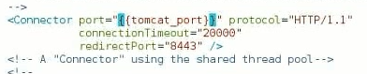

* Then rename the server.xml file to server.xml.j2





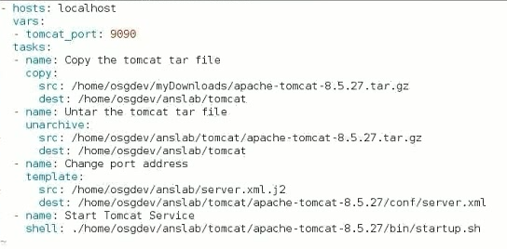

* After running the yml file, if we go and see the server.xml, the port will be 9090
* Where ever we want to change the configuration, we can use variables like this
* Port number is the additional identification of the address
* We can also use host_vars or group_vars for variables in templates
* There are many things in jinja2
* For us, capital letters, joining two things are important

**Examples:**

* Below is the yml file for template

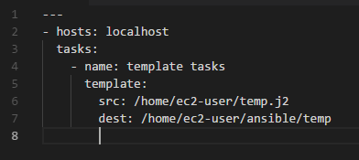

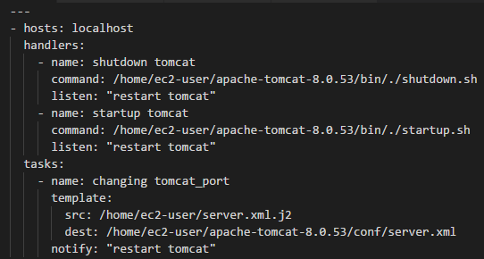

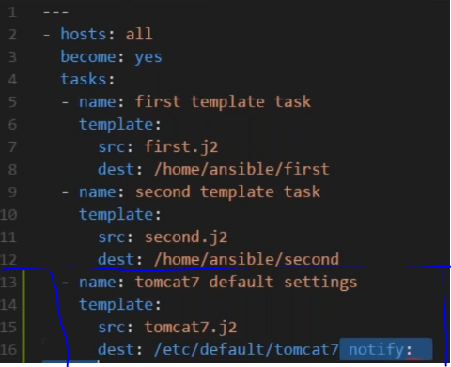

We also have “owner”, “group” and “mode” arguments in templates.

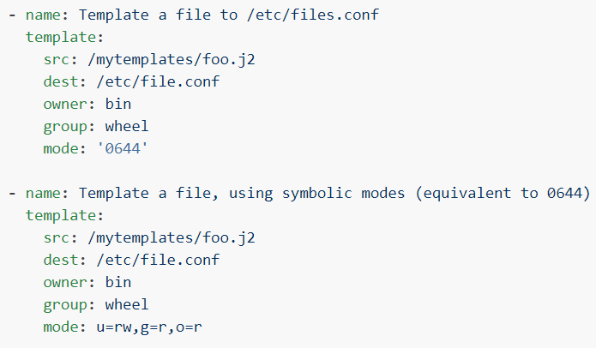

**Difference between template and copy:**

